STUDENT RECORD MANAGEMENT SYSTEM

OVERVIEW
The Student Record Management System is a simple, console-based Python application designed to help users manage and monitor student information efficiently. It allows users to add student records, view student details, search for specific students, delete records, and store student data permanently using file handling.

PROBLEM ADDRESSED
Managing student records manually can lead to data loss, errors in record keeping, difficulty in searching student information, and lack of record persistence. This project provides a basic digital solution for organizing and maintaining student data efficiently.

MAIN FEATURES
Add Student Record – Adds new student records with student details.
View Student Records – Displays all available student records.
Search Student by Student ID – Finds a specific student using a unique Student ID.
Delete Student Record – Removes a student record from the system.
Menu-driven Interface – Allows users to choose operations through a menu.
Input Validation – Prevents incorrect inputs and handles errors safely.
Data Persistence – Stores student data in a file for future use.

PYTHON CONCEPTS USED
Data Structures
Dictionary – Used to store student data with keys representing student attributes.
Lists – Used as values inside the dictionary to hold multiple student records.
Dictionary of Lists Structure – Each list index represents a single student record across all fields.
Efficient Data Management – Enables easy addition, searching, and deletion of student records.
Control Flow
While Loop – Used to repeatedly display the menu until the user chooses to exit.
If / Elif / Else Statements – Used to handle menu selection and decision-making logic.
For Loop – Used to iterate through student records for viewing and searching.
Functions
show_menu() – Displays the main menu options to the user.
add_student() – Adds a new student record.
view_students() – Displays all student records.
search_student() – Searches for a student using Student ID.
delete_student() – Deletes a student record.
save_to_file() – Saves student data to a file.
exit_program() – Exits the program safely after saving data.

METHODS USED
List Methods
append() – Used to add new student records to the list.
pop() – Used to remove student records from the list.
len() – Used to determine the number of student records.
Dictionary Methods
keys() – Used to access all dictionary keys.
values() – Used to access all dictionary values.
get() – Used to safely retrieve values from the dictionary.
String Methods
strip() – Used to remove extra spaces from user input.
title() – Used to format student names properly.

EXCEPTION HANDLING
try / except Block – Used to handle invalid user input such as entering text instead of numbers.
ValueError Handling – Prevents the program from crashing due to incorrect data types.
User-Friendly Messages – Displays clear error messages when an exception occurs.
Smooth Program Execution – Ensures the program continues running even after input errors.

FILE HANDLING AND LIBRARIES
File Handling – Student data is saved to and loaded from a file using the with open() statement.
Read and Write Operations – Files are opened in read ("r") and write ("w") modes to manage data persistence.
Data Persistence – Ensures student records are retained after program execution ends.
Libraries Used – Standard Python libraries along with pandas and numpy are used.

HOW TO RUN
- Open Jupyter Notebook or Python environment.
- Run the Student Record Management System file.
- Run all cells or the main program cell.
- Follow menu instructions displayed on the screen.

INPUT AND USAGE GUIDELINES
Numeric Inputs – Student ID, Semester, and Marks must be entered as numbers only.
Text Inputs – Student Name and Course should be entered as text.
Menu Selection – Users must select menu options using the corresponding numbers.
Invalid Input Handling – The program displays an error message if incorrect input is entered.
Exit Procedure – Users should choose the exit option to safely close the program and save data.

FILE AND DATASET DETAILS
Data File Name – Student records are stored in a file named students.txt.
File Location – The data file is stored in the same folder as the Python program.
Stored Fields – Student ID, Student Name, Course, Semester, and Marks.
File Creation – If the file does not exist, it is created automatically when data is saved.
Data Loading – Student data is loaded from the file when the program starts.

TESTING AND SCREENSHOTS
Useful test scenarios
Viewing all student records.

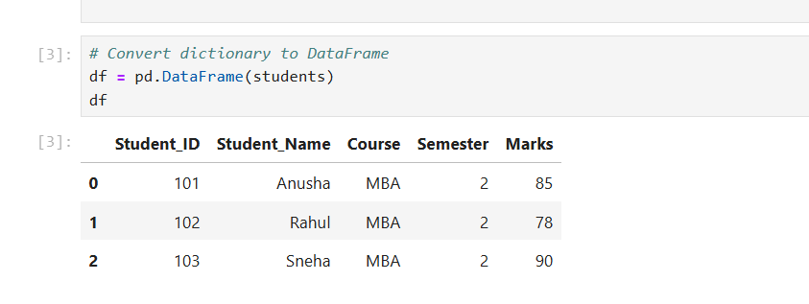

Adding a new student record.

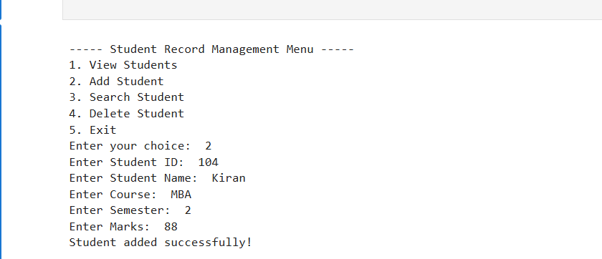

Searching a student by Student ID.
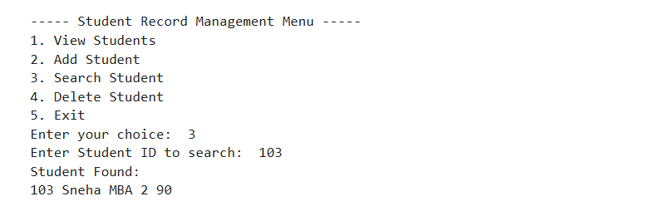
Deleting a student record.
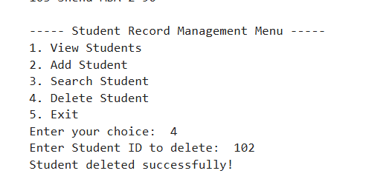
ASSIGNMENT FIT AND EXTRAS
Meets Assignment Requirements – Fully satisfies all Python mini-project guidelines.
Real-World Application – Addresses a practical problem in student record management.
Structured Programming – Uses functions, loops, and conditionals effectively.
Error Handling – Includes exception handling to manage invalid inputs.
Data Persistence – Implements file handling to save and load student records.
Easy to Extend – Can be enhanced with additional features if required.

AUTHOR DETAILS
Name: Anusha DS
USN: 1BG24BA013
Course: Python Programming
Project: Student Record Management System
Domain: Education / Academic Management

